Where Does a Star get its Energy From?
The sun is a star. The stars you see in the night sky are suns. Our sun is just one of innumerable other suns.
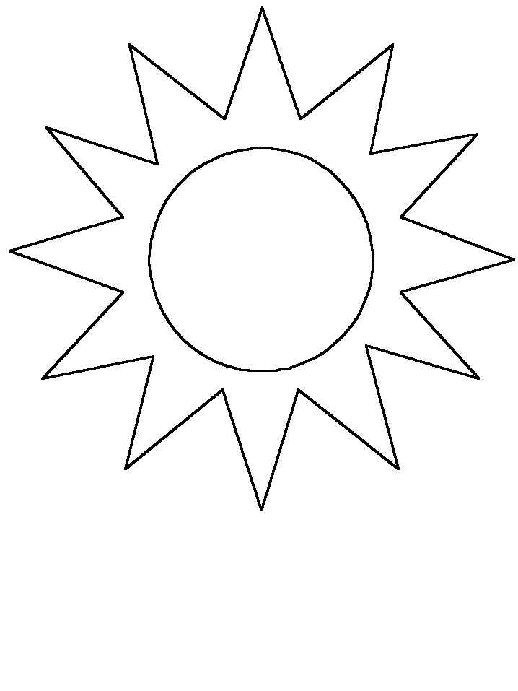
In a star 2 hydrogen atoms are joined together to make one helium atom. This happens over and over again, with many hydrogen atoms. When two atoms are fused together to make another element it is called nuclear fusion. When this fusion occurs a lot of energy is released. This is how a star gets its energy.
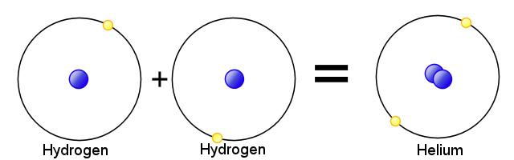
The reason this can happen is because the sun is huge and has a lot of gravity.
Gravity is the force of attraction between all matter. It is the gravity that causes enough pressure to “squash” (fuses) the hydrogen atoms together.
In space we find Nebula. Nebulae are clouds of dust and gas. Slowly the dust and gas comes together due to gravity. Eventually the cloud becomes very dense with a lot of gravity. This gravity gives enough pressure to cause the fusion.
Word | Meaning
Nuclear fusion
Gravity
Nebula

